**Building an Automobile Management Application using Windows Forms and ADO.NET**

# Introduction

Imagine you're an employee of a car retailer named **Automobile Store**. Your manager has asked you to develop a Windows Forms application for automobile management (CarID, CarName, Manufacturer, Price, and ReleasedYear). The application has to support adding, viewing, modifying, and removing products—a standardized usage action verbs better known as Create, Read, Update, Delete (CRUD).

This lab explores creating an application using Windows Forms with .NET Core, and C#. An **SQL Server** **Database** will be created to persist the car's data that will be used for reading and managing automobile data by **ADO.NET**

# Lab Objectives

In this lab, you will:

* Use the Visual Studio.NET to create Windows Forms and Class Library (.dll) project.
* Create a SQL Server database named MyStock that has a Cars table.
* Develop a DataProvider class to perform CRUD actions using ADO.NET
* Apply passing data in WinForms application
* Apply Repository pattern and Singleton pattern in a project
* Add CRUD action methods to WinForms application
* Run the project and test the WinForms actions.

# MyStock Database

# 

# Activity 01: Build a solution by Visual Studio.NET

Create a Blank Solution named **AutomobileSolution** then add new a Class Library Project named **AutomobileLibrary** and a Windows Forms project named **AutomobileWinApp**

**Step 01**. Create a Blank solution.

* Open the Visual Studio .NET application and performs steps as follows:

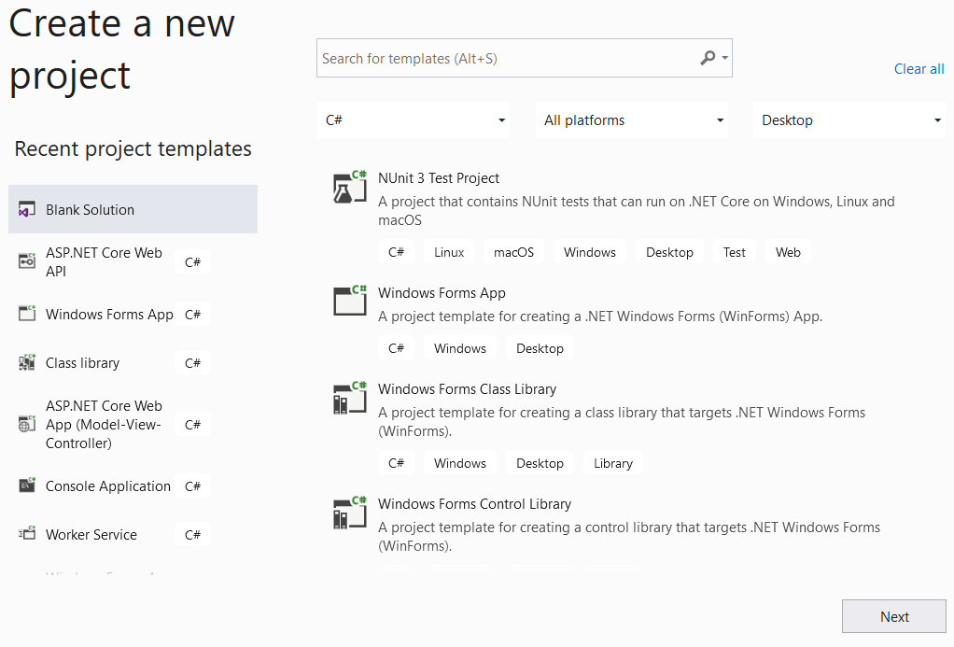

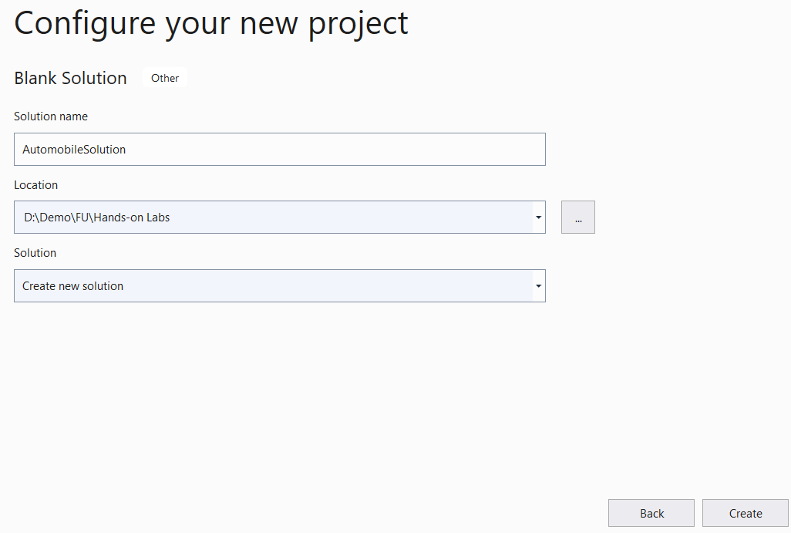

**Step 02.** Create a Class Library project.

* From the File menu | Add | New Project, on the Add New Project dialog, select “Class Library” and performs steps as follows:

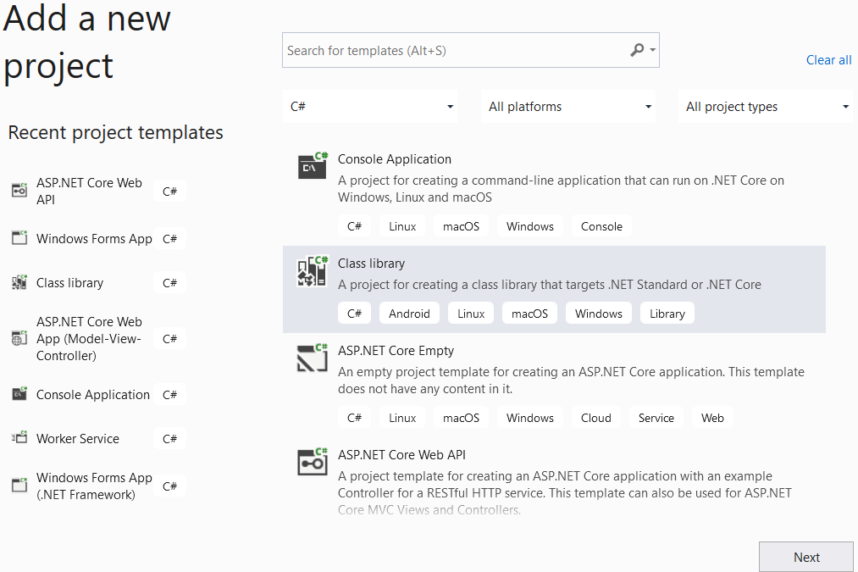

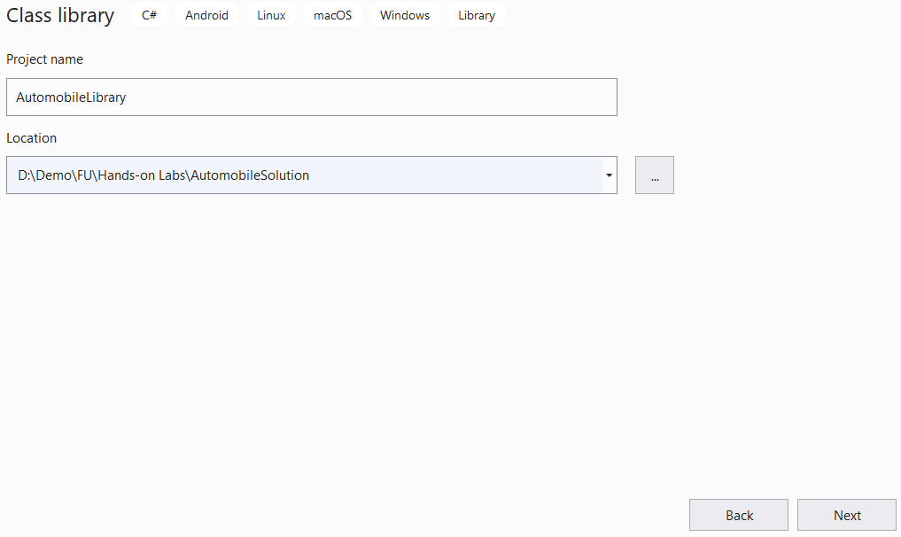

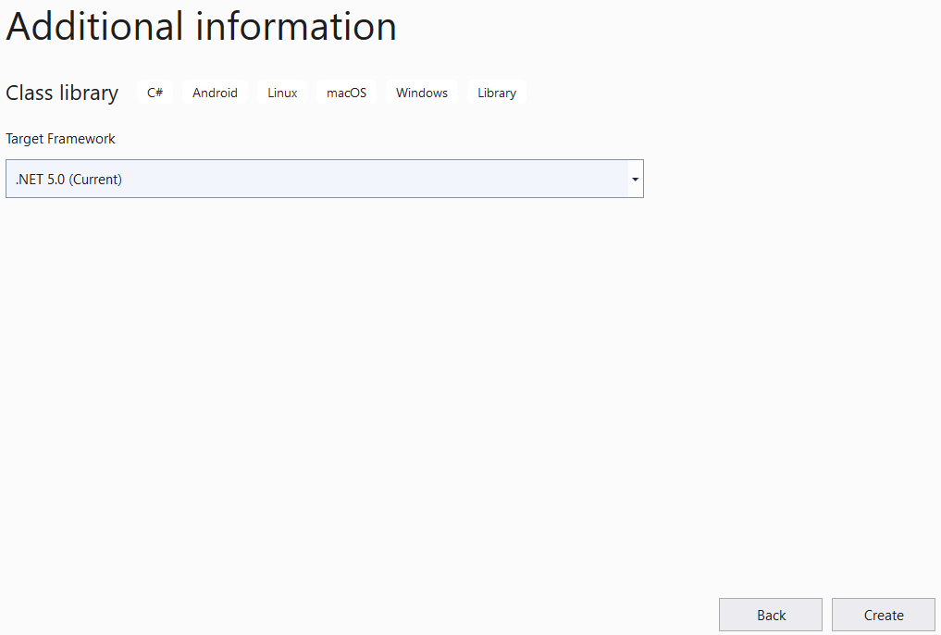

**Step 03.** Repeat **Step 02** to create a Windows Form project.

# Activity 02: Write codes for the AutomobileLibrary project

**Step 01**. Create folders and add classes to the project as follows:

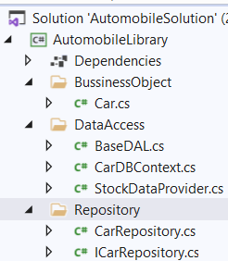

**Step 02**. Write codes for **Car.cs** as follows:

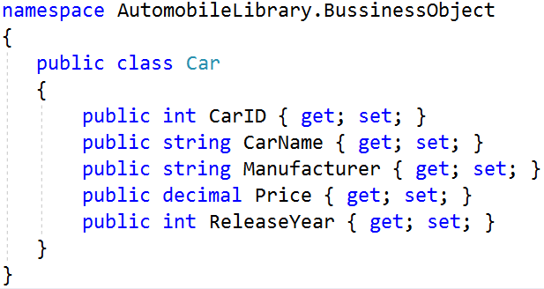`

**Step 03**. Install the following packages from Nuget:

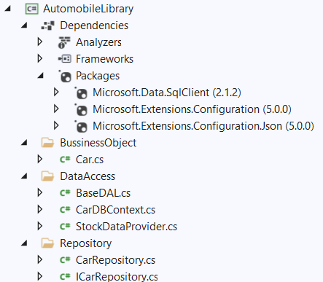

**Step 04**. Write codes for **StockDataProvider.cs** as follows:

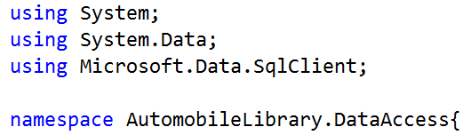

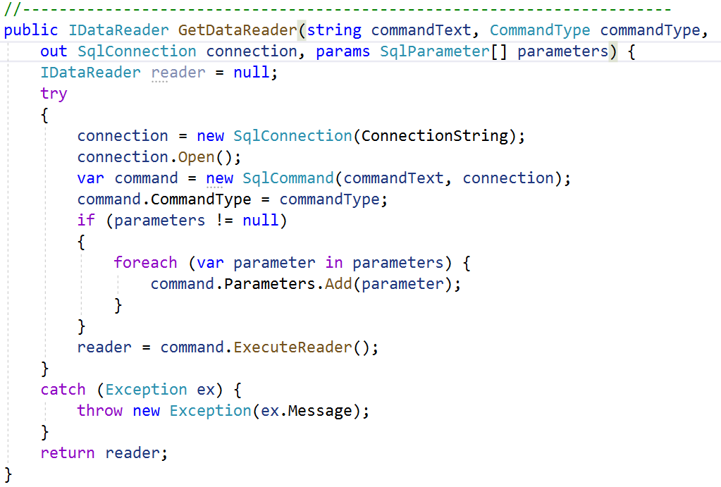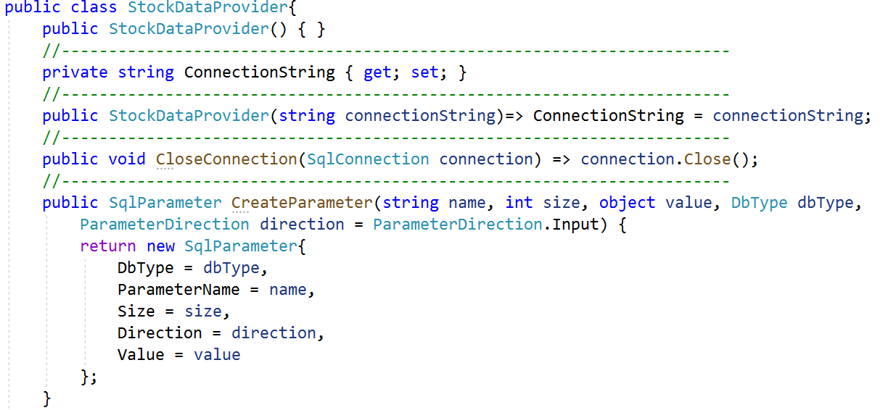

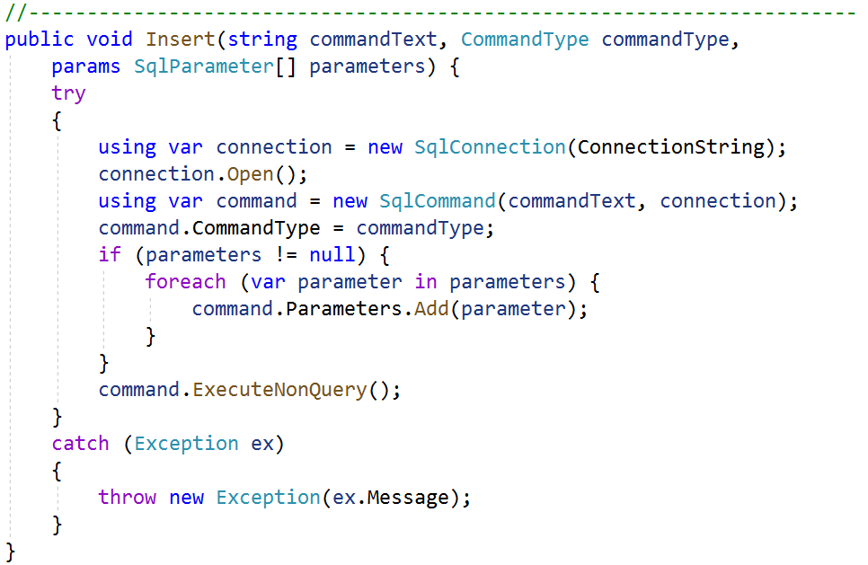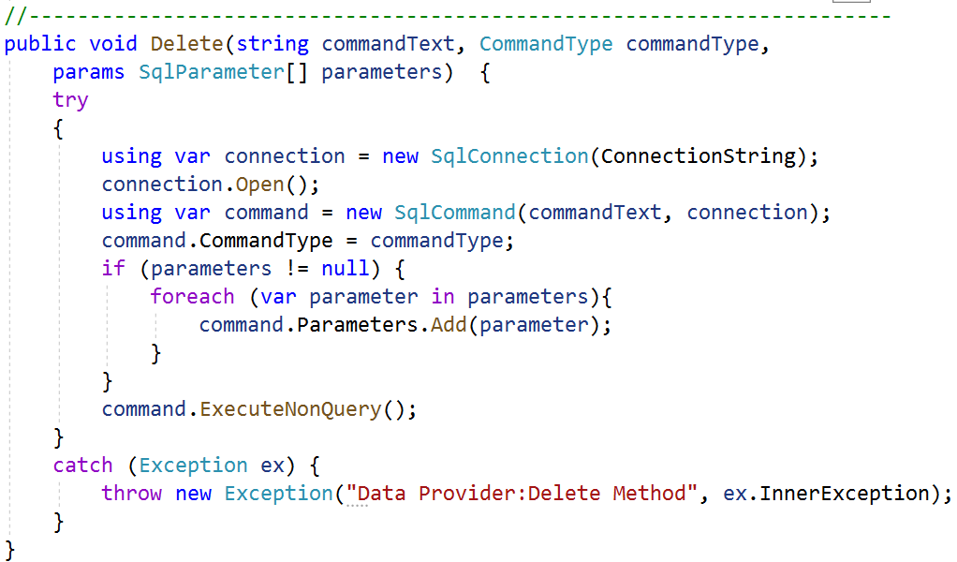

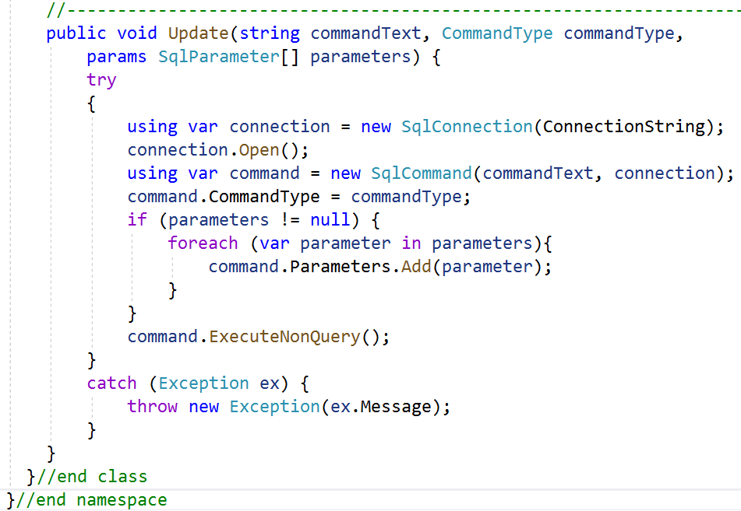

**Step 05**. Write codes for **BaseDAL.cs** as follows:

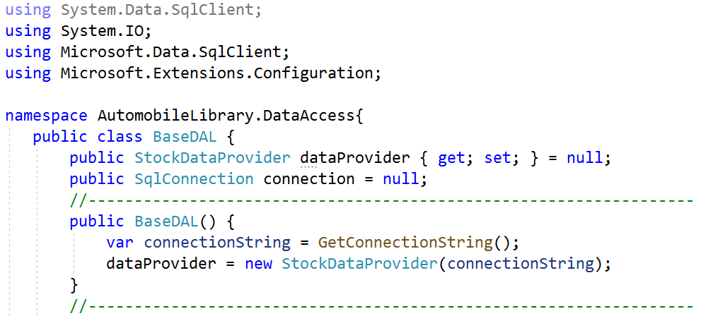

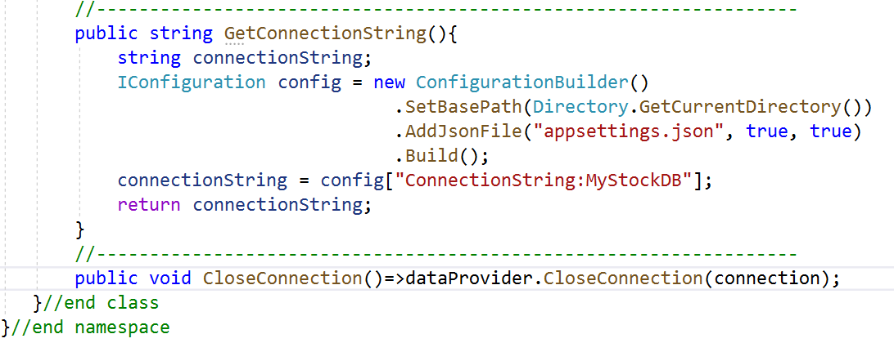

**Step 06**. Write codes for **CarDBContext.cs** as follows:

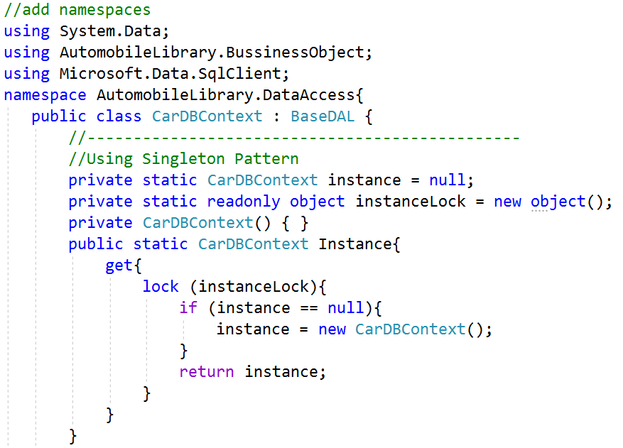

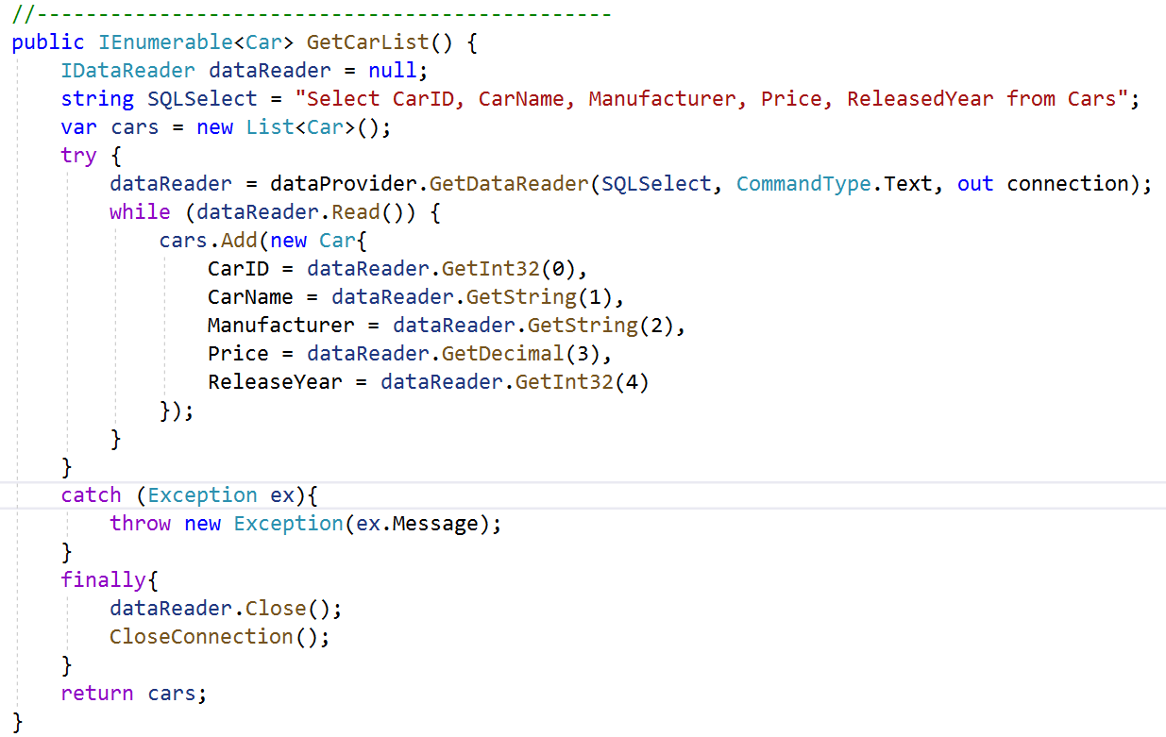

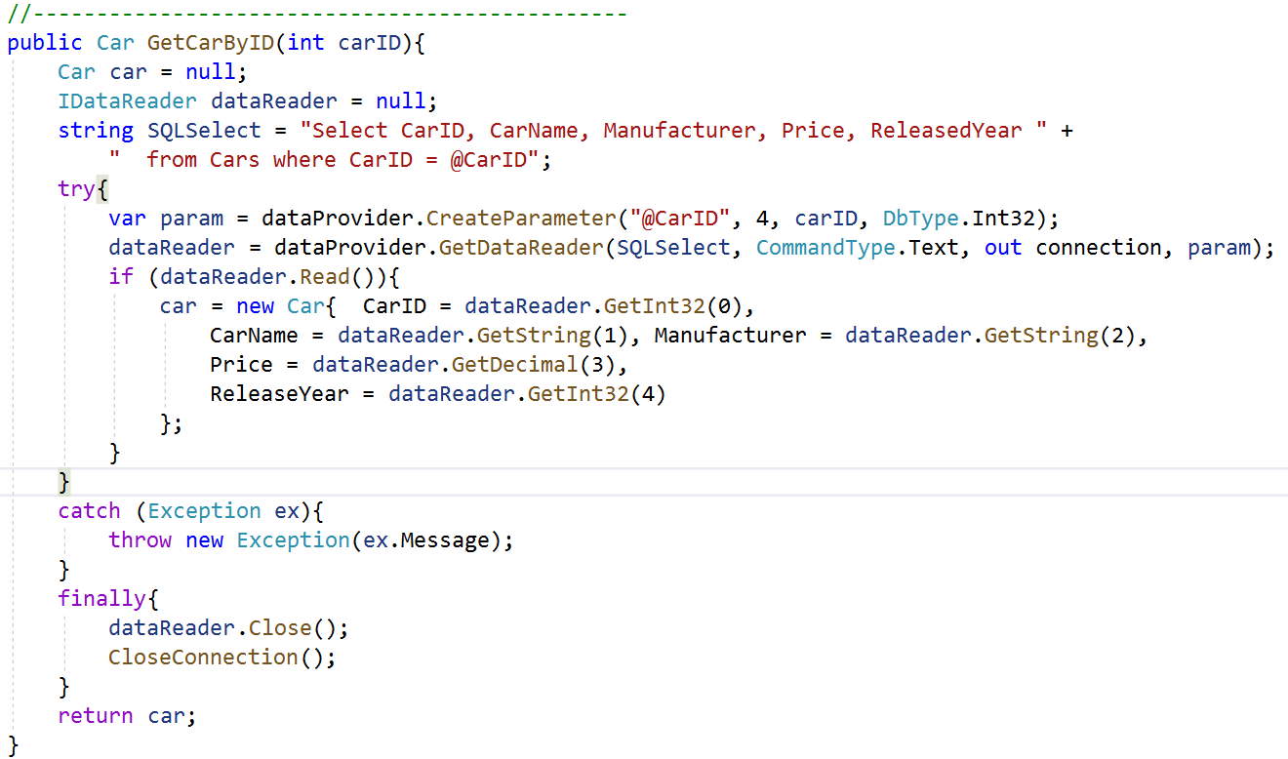

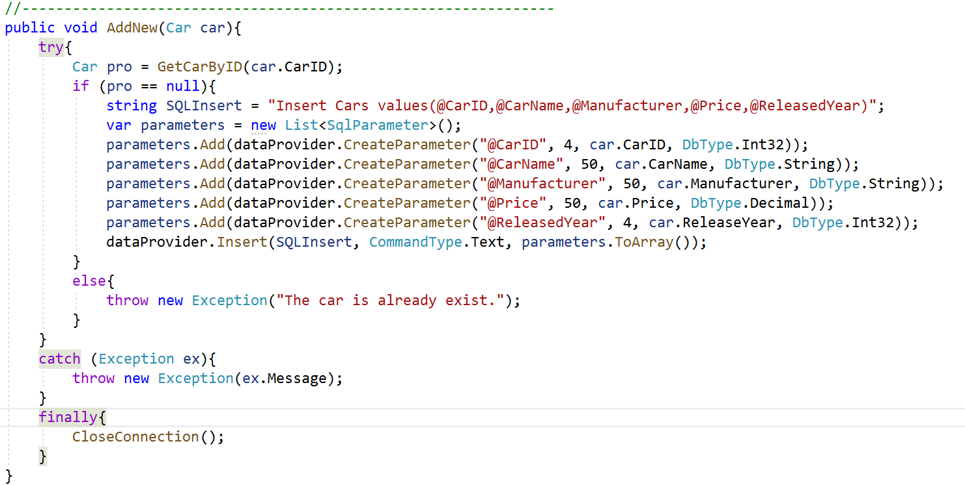

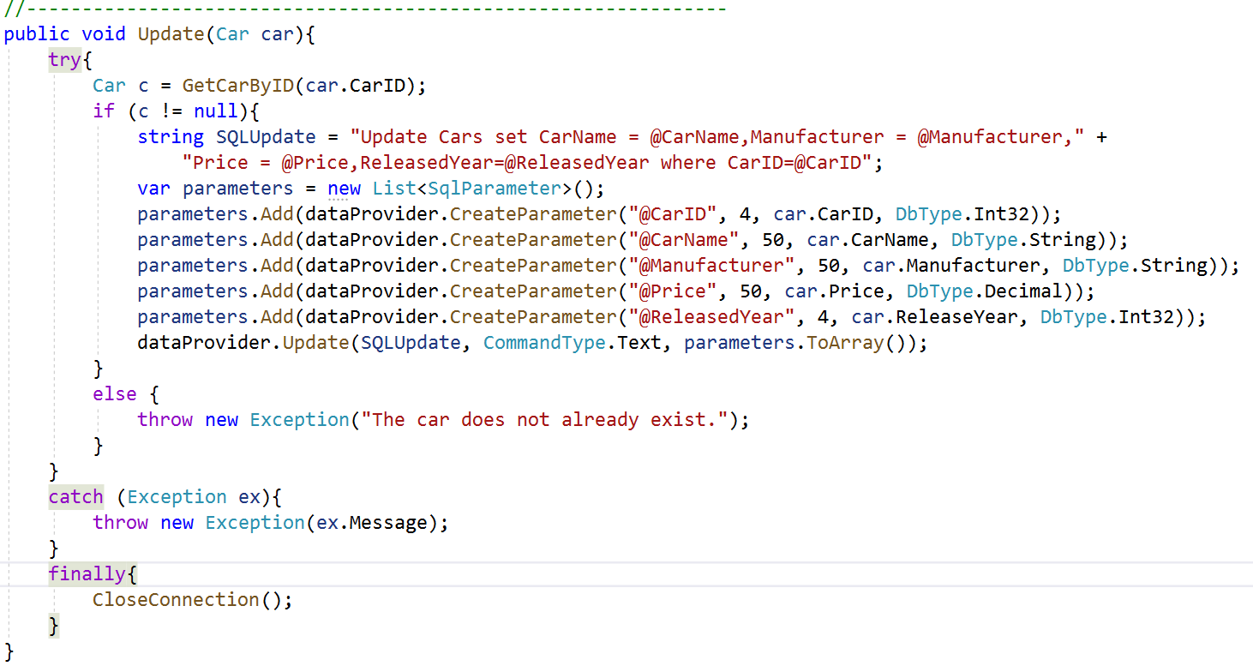

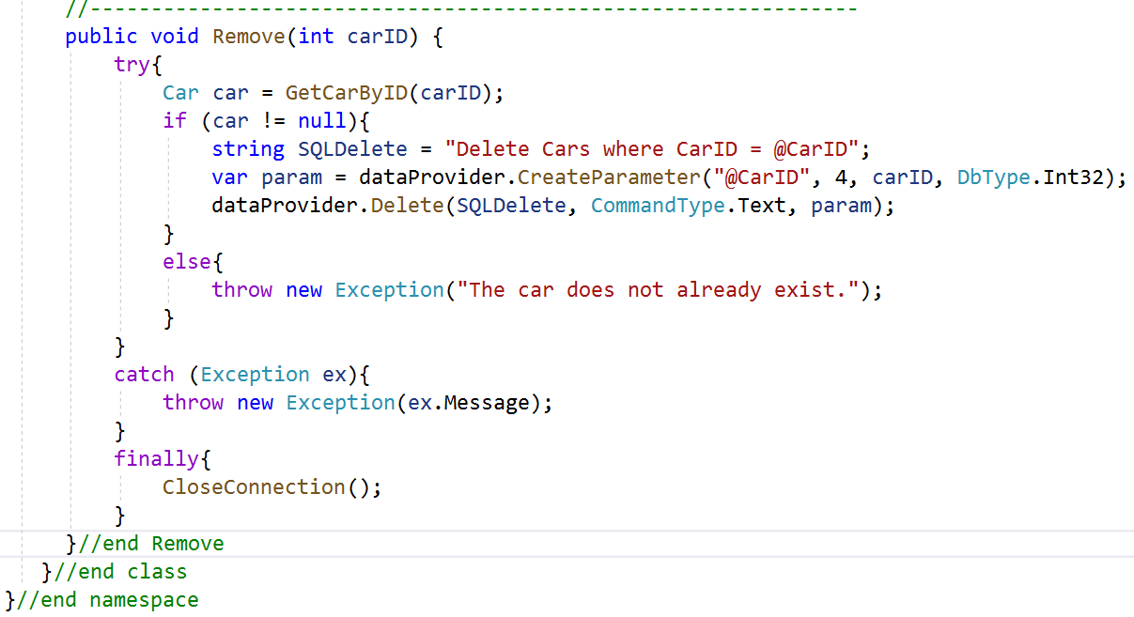

**Step 07**. Write codes for **ICarRepository.cs** as follows:

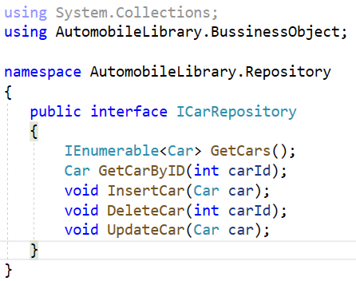

**Step 08**. Write codes for **CarRepository.cs** as follows:

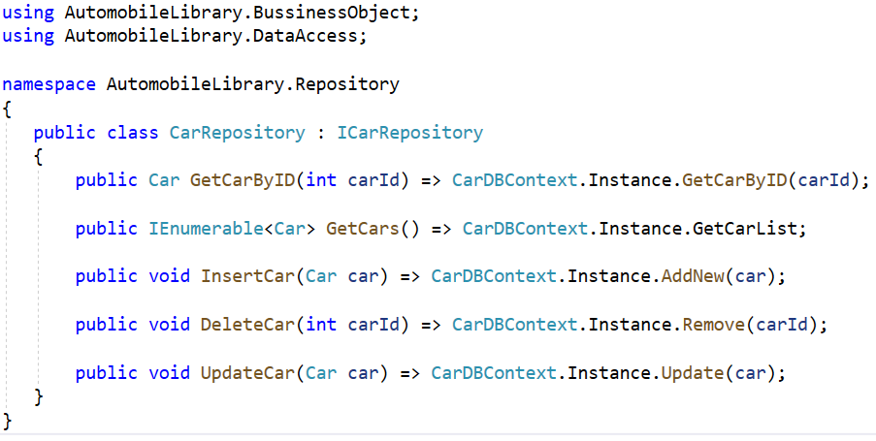

# Activity 03: Design UI and write codes for WinForms project

**Step 01**. Right-click on the **AutomobileWinApp** project and add a new form named **frmCarDetails.cs** with UIas follows:

# 

|  |  |  |  |
| --- | --- | --- | --- |
| No. | Object Type | Object name | Properties / Events |
| 1 | Label | lbCarID | Text: Car ID |
| 2 | Label | lbCarName | Text: Car Name |
| 3 | Label | lbManufacturer | Text: Manufacturer |
| 4 | Label | lbPrice | Text: Price |
| 5 | Label | lbReleaseYear | Text: ReleaseYear |
| 6 | TextBox | txtCarID |  |
| 7 | TextBox | txtCarName |  |
| 8 | MaskedTextBox | txtPrice | Mask: 000000000  Text: 0 |
| 9 | MaskedTextBox | txtReleaseYear | Mask: 0000  Text: 0 |
| 10 | ComboBox | cboManufacturer | Items:  Audi  BMW  Ford  Honda  Hyundai  Kia  Suzuki  Toyota |
| 11 | Button | btnSave | Text: Save  DialogResult: OK  Event Handler: Click |
| 12 | Button | btnCancel | Text: Cancel  DialogResult: Cancel  Event Handler: Click |
| 13 | Form | frmCarDetails | StartPosition: CenterScreen  Text: frmCarDetails  Event Handler: Load |

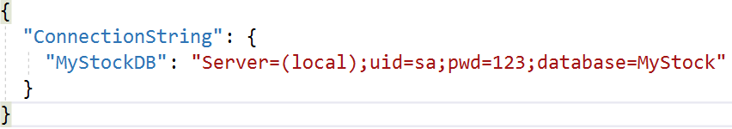**Step 02**. Right-click on the project | Add | New Item, select **JavaScript JSON Configuration File** then rename to **appsettings.json** , click Add and write contents as follows:

**Step 03.** Right-click on the project, select **Edit Project File,** and write config information as follows then press Crtl+S to save:

<Project Sdk="Microsoft.NET.Sdk">

<PropertyGroup>

<OutputType>WinExe</OutputType>

<TargetFramework>net5.0-windows</TargetFramework>

<UseWindowsForms>true</UseWindowsForms>

</PropertyGroup>

<ItemGroup>

<ProjectReference Include="..\AutomobileLibrary\AutomobileLibrary.csproj" />

</ItemGroup>

<ItemGroup>

<None Update="appsettings.json">

<CopyToOutputDirectory>Always</CopyToOutputDirectory>

</None>

</ItemGroup>

</Project>

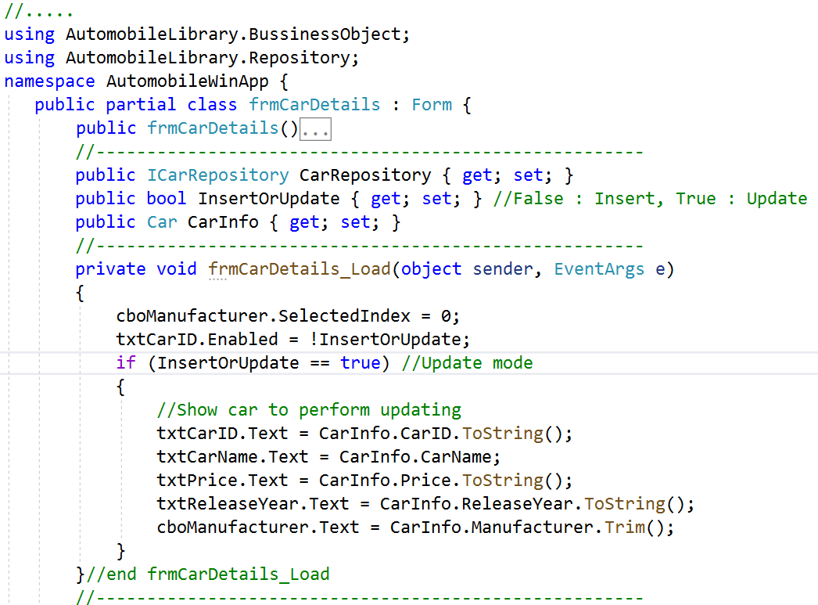**Step 04**. Write codes for **frmCarDetails.cs**:

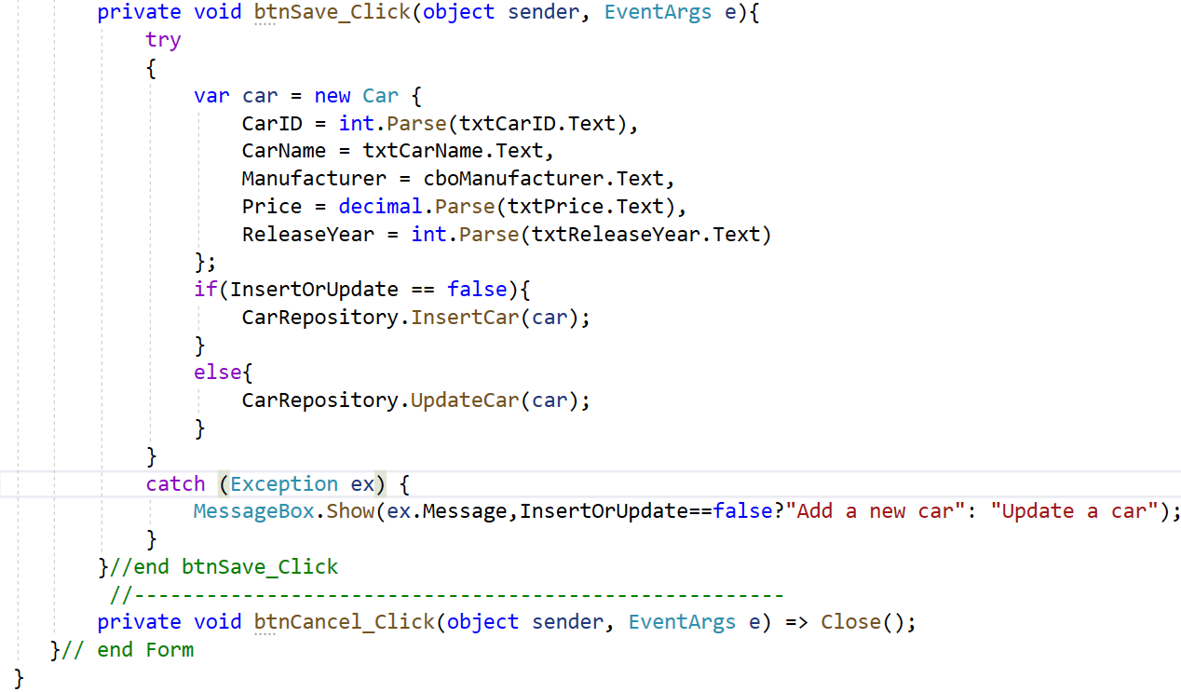**Step 05**. Design UI for **frmCarManagement.cs** form:

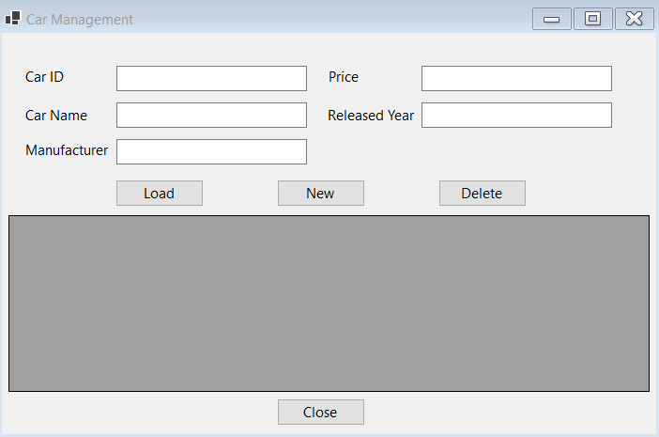

|  |  |  |  |
| --- | --- | --- | --- |
| No. | Object Type | Object name | Properties / Events |
| 1 | Label | lbCarID | Text: Car ID |
| 2 | Label | lbCarName | Text: Car Name |
| 3 | Label | lbManufacturer | Text: Manufacturer |
| 4 | Label | lbPrice | Text: Price |
| 5 | Label | lbReleaseYear | Text: ReleaseYear |
| 6 | TextBox | txtCarID |  |
| 7 | TextBox | txtCarName |  |
| 8 | TextBox | txtPrice |  |
| 9 | TextBox | txtReleaseYear |  |
| 10 | TextBox | txtManufacturer |  |
| 11 | Button | btnLoad | Text: Load  Event Handler: Click |
| 12 | Button | btnNew | Text: New  Event Handler: Click |
| 13 | Button | btnDelete | Text: Delete  Event Handler: Click |
| 14 | DataGridView | dgvCarList | ReadOnly: True  SelectionMode:FullRowSelect |
| 15 | Form | frmCarManagement | StartPosition: CenterScreen  Text: Car Management  Event Handler: Load |

# Activity 04: Reference to AutomobileLibrary project and write code for WinForms project

# Step 01. Right-click on AutomobileWinApp project, select Add | Project Reference, and perform as the below figure:

# 

# Step 02. Write codes for frmCarManagement.cs

# 

# 

# 

# 

# 

# Activity 06: Press Ctrl+F5 to run the WinForms project and test all actions

# Step 01. Click Load button and display the result as the below figure.

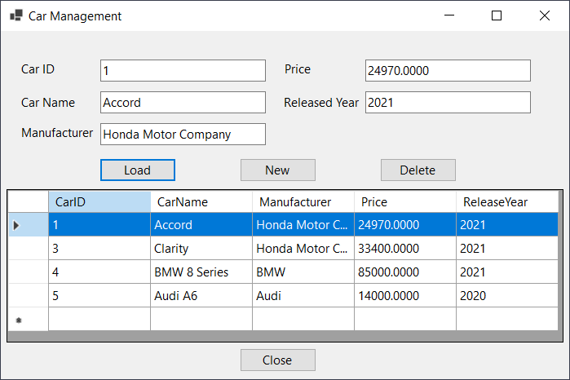

# Step 02. Click New button and display the result as the below figure, enter the values on TextBoxes then click Save to add a new car.

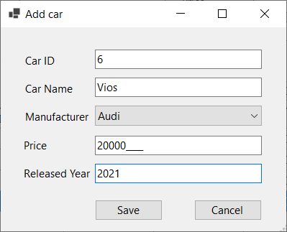

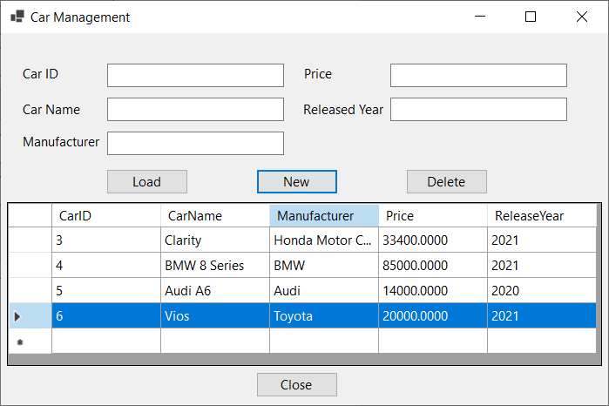

# Step 03. Select a row on the DataGridView then click Delete to remove a Car.

**Step 04**. Double-click a row on the DataGridView to update a Car on the popup form, edit values then click **Save** to update.

# 